From: https://rwmalonemd.substack.com/p/monkey-pox-update?utm_source=substack&utm_medium=email

Monkey Pox Update

May 31, 2022. There has been a significant development.
Robert W Malone MD, MS
May 31, 2022
Readers: 1,043
Commenters: 235

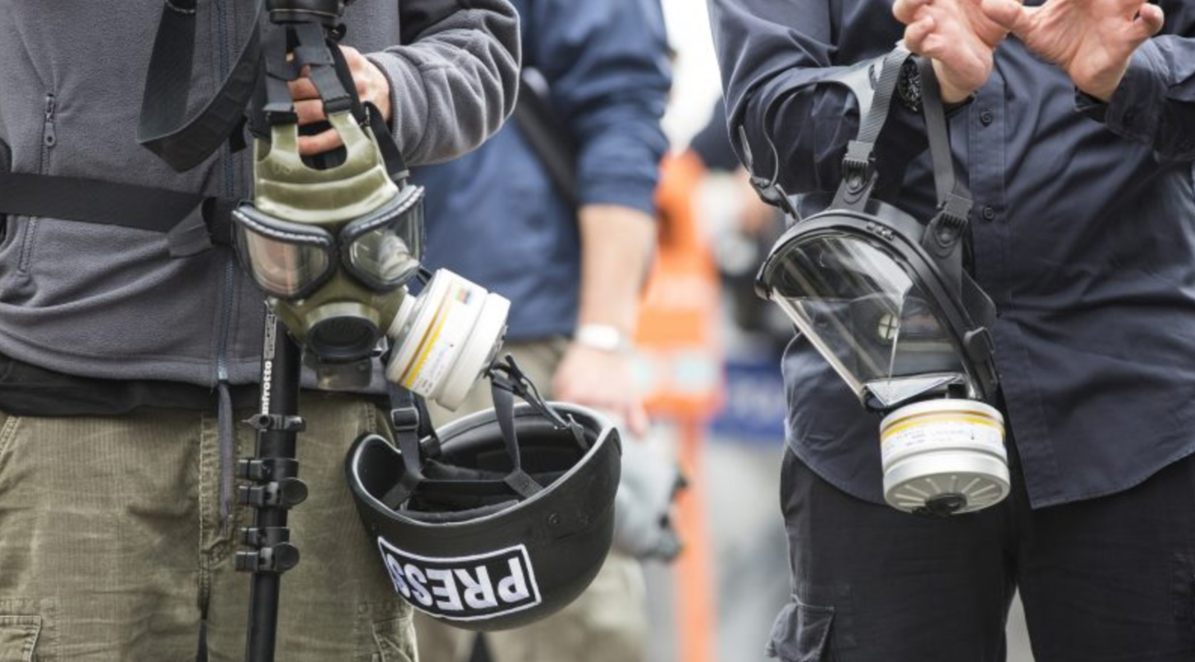

Will the blatant fearporn ever stop? The controlled media have no shame.
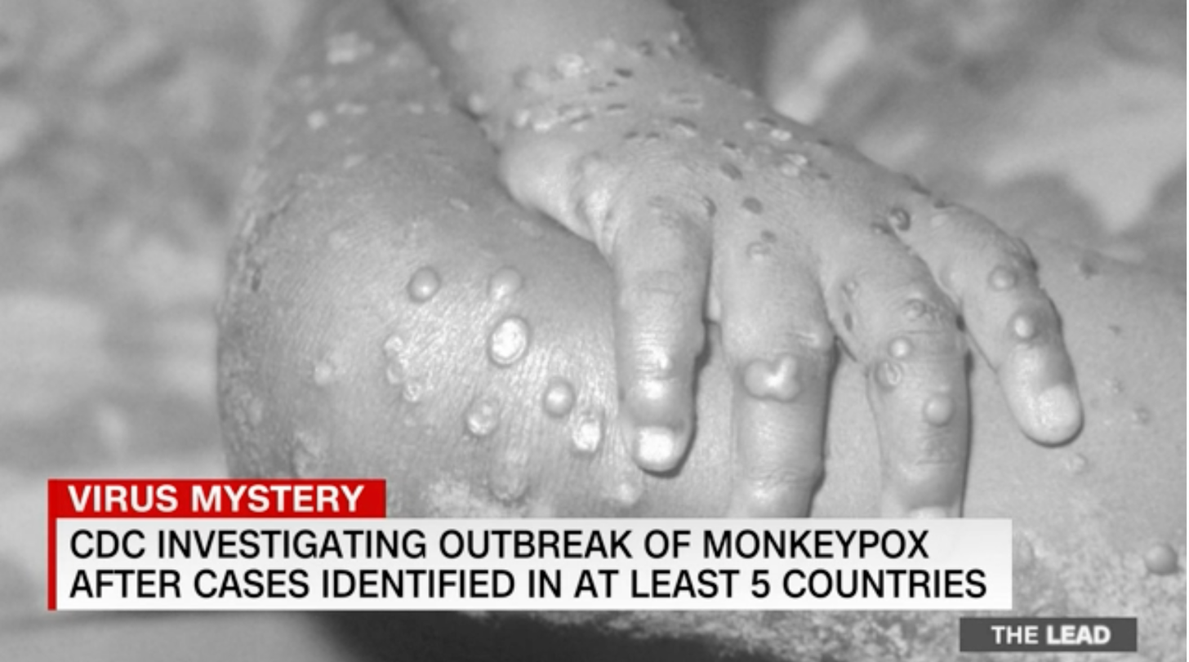
If Ronald Reagan were still with us, I suspect we would be hearing “There you go again” replays. First came the coordinated media blast of public health-related fearporn. For example, the image from Jake Tapper’s CNN broadcast program “The Lead” of May 20,2022 (above) which appears to me to be a case of smallpox, not monkeypox. Another example involves the self-explanatory paired images below.
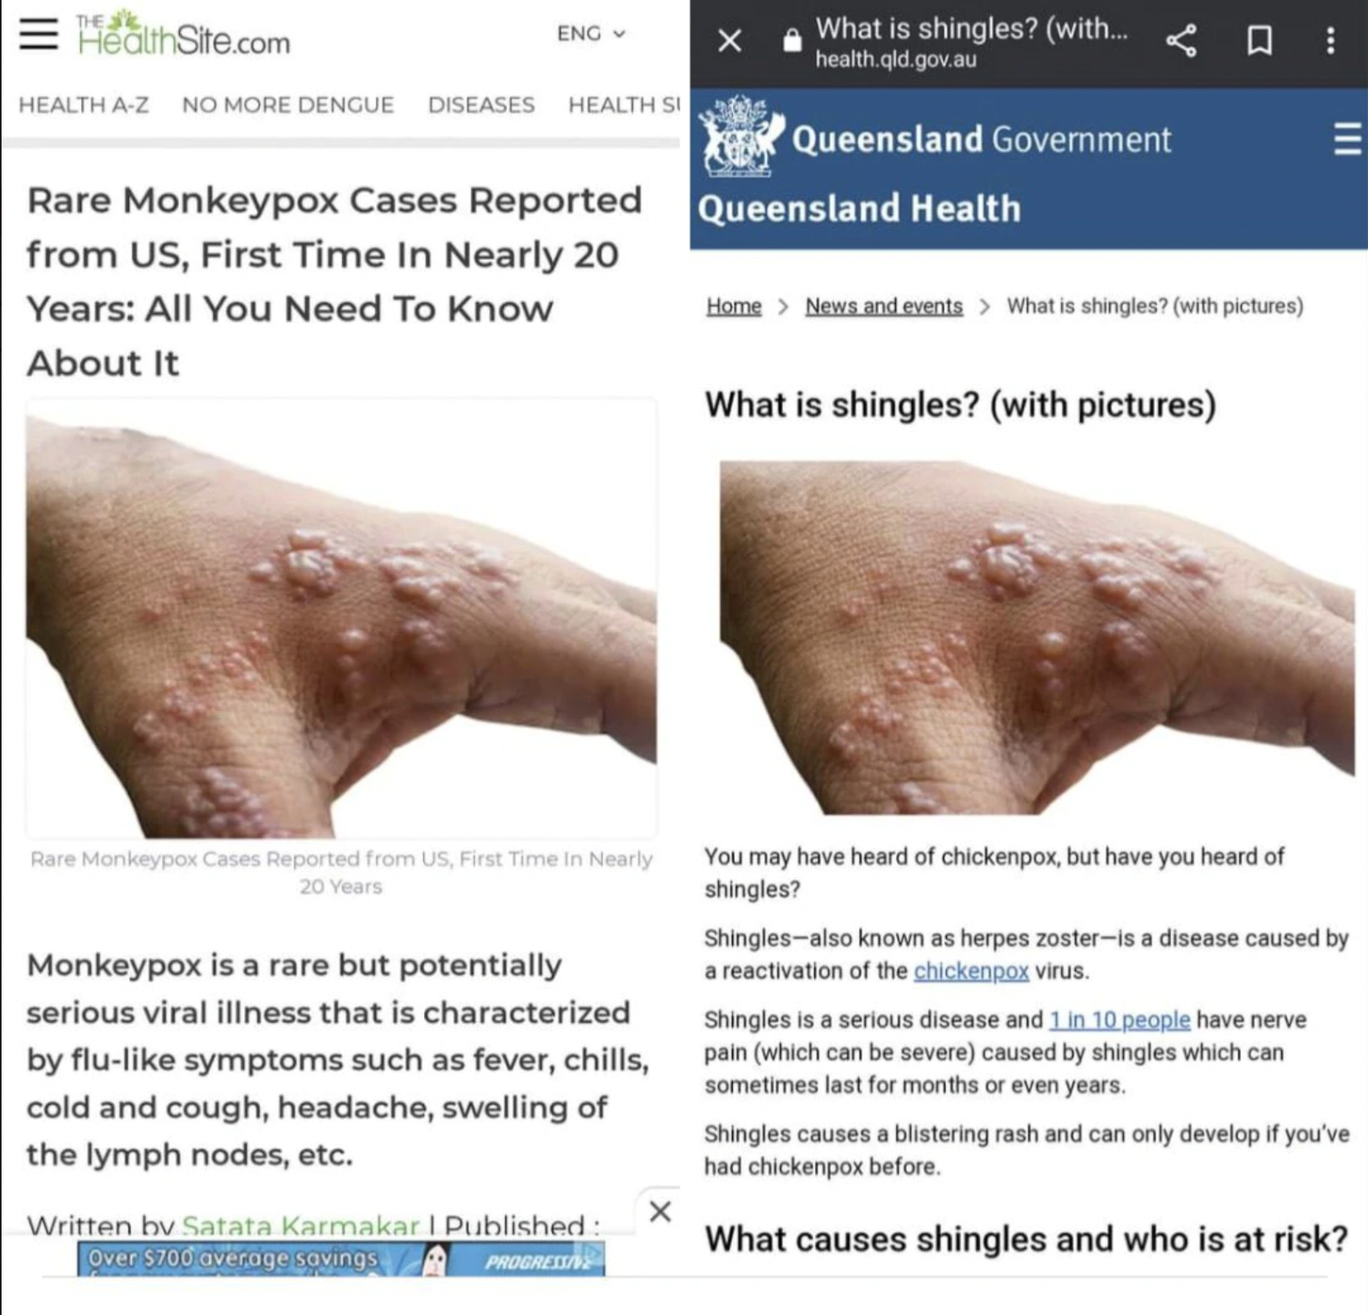
And of course the Bill and Melinda Gates - funded GAVI text which is quite blatant, claiming 10% mortality, which I covered in my prior substack article concerning Monkeypox and fearporn.
I almost cannot believe that I am writing this, but since my original substack article on this topic [monkeypox],
we had the reveal of an Event 201-style wargame exercise modeled around a bioterror-related release of an engineered Monkeypox virus “caused by a terrorist attack using a pathogen engineered in a laboratory with inadequate biosafety and biosecurity provisions and weak oversight.” With amazing (coincidental?) prescience, the “table top exercise” of March 2021 (one year and three months into the Covidcrisis) models a Monkeypox bioterror attack initiated on May 15, 2022. Note the date of the CNN/Jake Tapper fearporn piece - May 20, 2022. The modeling deployed in the scenario upon which the “exercise” was based predicts 3.2 billion cases and 271 million deaths by December 01, 2023. Of course, the predictive accuracy of the simplistic public health models such as that used to support this scenario have repeatedly proven to be absolutely horrid, and these types of models should be either relegated to the trash heap (or ongoing dumpster fire) as unscientific speculation which is all too frequently weaponized by the fearporn peddlers such as CNN, MSNBC, NYT, Washington Post. By now we all know the usual USG and WEF-controlled media players.
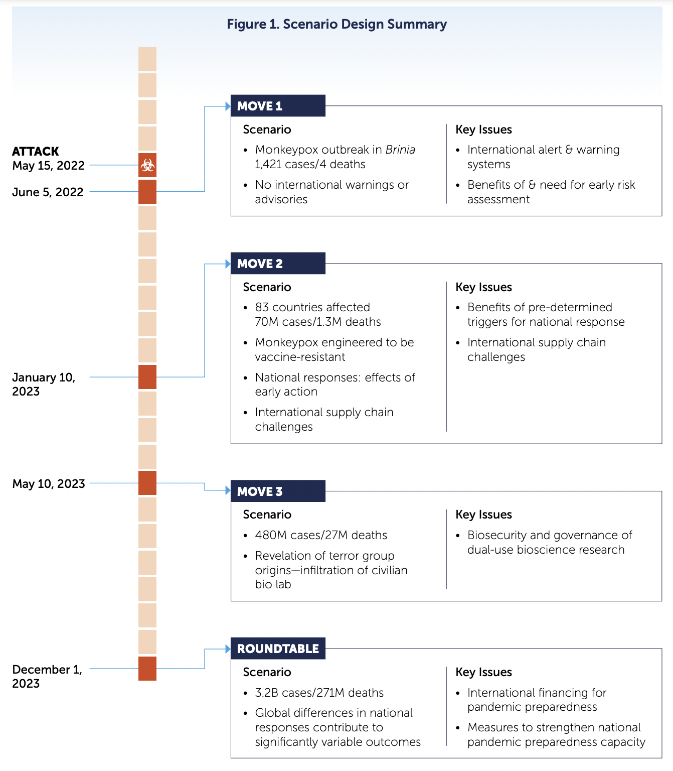
As the Italian’s like to say:
Niente e lasciato al caso.
Nothing happens by chance.
As we now know, the amazing foresight of this modeled date immediately preceded a seminal WHO meeting which has just concluded, in which international health regulation (IHR) modifications which would grant the WHO unprecedented powers to bypass national constitutions (proposed on January 23, 2022 by the US HHS) were actively considered but tabled for a future meeting (~November 2022?) largely due to African nation concerns regarding infringement of national sovereignty. The stated purpose of the “exercise” was remarkably well aligned with the stated objectives and topics proposed by US HHS in the submitted IHR modifications:
- To establish a new global biosecurity entity dedicated to reducing emerging biological risks that can accompany certain technology advances. Its mission will be to reduce the risks of catastrophic consequences due to accidents, inadvertent misuse, or deliberate abuse of bioscience and biotechnology by promoting stronger global biosecurity norms and developing tools and incentives to uphold them.
- To explore the possibility of establishing a new Joint Assessment Mechanism to investigate high consequence biological events of unknown origin. This new mechanism would operate at the “seam” between existing mechanisms—including World Health Organization (WHO) outbreak investigation capabilities and the United Nations Secretary-General’s Mechanism for investigating alleged deliberate bioweapons use—thereby strengthening UN system capabilities to investigate pandemic origins.
- To advocate for establishing a catalytic, multilateral financing mechanism for global health security and pandemic preparedness. The goal is to accelerate sustainable biosecurity and pandemic preparedness capacity-building in countries where resources are most needed.
So, do we have yet another example of a “Plandemic”?
[After finishing this document, one must be inclined to think, YES. With risk likelihood (think, probability) up around 0.95. –FNC]
All I can say is ~
"Oh! What a tangled web we weave, when first we practice to deceive"
(Sir Walter Scott, Marmion)
Or perhaps the more appropriate quote would be ~
The Italians having a Proverb, “He that deceives me once, its’ his fault; but if twice, its’ my fault.”
Anthony Weldon, The Court and Character of King James (1651)
In my prior substack entitled “Monkey Pox, Truth versus Fearporn”, I concluded the essay with the following caveat:
Unless there has been some genetic alteration, either through evolution or intentional genetic manipulation, it is not a significant biothreat, and has never been considered a high threat pathogen in the past.

Which brings us to this May 23, 2022 report from the Portuguese National Institute of Health.
Just to set the stage, the outbreak seems to be tightly associated with a point of origin at what appear to have been two large European dance party events (“Raves”), in the Canary Islands (“Gay Pride event in the Canary Islands, which drew some 80,000 people”) and “a Madrid sauna”. The Canary Islands event was the 20th anniversary of “Maspalomas Gay Pride”, which took place from May 05 to May 15 (the precise date of the previously modeled Monkeypox bioweapon release). The organizers anticipated “a huge parade with over 100,000 participants, boat trips, pool parties and more!”. So, basically, pretty much a perfect opportunity for a Monkeypox super spreader event, whether intentional or inadvertent. Donning my “cynical skeptic” tinfoil hat for a moment, if one was looking for an opportunity to seek a pathogen into a highly mobile international population, mindful of the early history of HIV-based AIDS, this would be just what the doctor (Mengle…) ordered.
Multiple cases were soon detected in Portugal, and to their great credit, INSA Portugal got busy and promptly did the deep sequencing necessary to enable building a phylogenic map of the Monkeypox variant associated with the outbreak.
Based on their findings, they have rapidly disclosed both their data as well as a series of startling hypothesis [ses] regarding the origin of the currently circulating Monkeypox (West African Clade) Monkeypox. Cutting to the chase, having reviewed their data and paper, I now have to conclude that one of the many “working hypotheses” concerning the origin of this particular virus must be that it is the product of laboratory-based manipulation - precisely as previously modeled by the Nuclear Threat Initiative (NTI):Bio/Munich Security Conference . True story. Truth continues to be stranger than fiction. [These 2 sentences are an interjection by Robert Malone, as reader like any of us. –FNC]
The authors briefly (and elegantly) summarize the study purpose and methods as follows:
Following the (First draft genome sequence of Monkeypox virus associated with the suspected multi-country outbreak, May 2022 (confirmed case in Portugal) 184), we now release 9 additional genome sequences of Monkeypox virus causing a multi-country outbreak. These sequences were obtained from clinical specimens collected from 9 patients on May 15th and 17th, 2022 through high throughput shotgun metagenomics using Illumina technology (see details bellow), with depth of coverage throughout Monkeypox genome ranging from 38x to 508x (mean of 201x).
The rapid integration of the newly sequenced genomes into the Monkeypox genetic diversity, also including the sequence released by USA* (Gigante et al, Monkeypox virus isolate MPXV_USA_2022_MA001, complete genome - Nucleotide - NCBI 156).
They then proceed to raise the following main observations:
- The multi-country outbreak most likely has a single origin, with all sequenced viruses released so far* tightly clustering together (Figure 1).
- Confirmation of the phylogenetic placement unveiled by the first draft sequence Isidro et al, 183: the outbreak virus belongs to the West African clade and is most closely related to viruses (based on available genome data) associated with the exportation of monkeypox virus from Nigeria to several countries in 2018 and 2019, namely the United Kingdom, Israel and Singapore (1, 2).
- Still, the outbreak virus diverges a mean of 50 SNPs from those 2018-2019 viruses (46 SNPs from the closest reference MPXV_UK_P2, MT903344.1) (Table 1_2022-05-23.zip (15.0 KB)), which is far more than one would expect considering the estimated substitution rate for Orthopoxviruses (3).
- As also mentioned by Rambaut (Discussion of on-going MPXV genome sequencing 228), one cannot discard the hypothesis that the divergent branch results from an evolutionary jump (leading to a hypermutated virus) caused by APOBEC3 editing (4)
- We have already detected the first signs of microevolution within the outbreak cluster, namely the emergence of 7 SNPs (Table 2_2022-05-23.zip (10.9 KB)), leading to 3 descendant branches (Figure 1) including a further sub-cluster (supported by 2 SNPs) involving 2 sequences (PT0005 and PT0008). Notably, these two sequences also share a 913bp frameshift deletion in MPXV-UK_P2-010 gene coding for an Ankyrin/Host Range (Bang-D8L); D7L protein (MT903344.1 annotation). Gene loss events were already observed in the context endemic Monkeypox circulation in Central Africa, being hypothesized to correlate with human-to-human transmission (5).
Those not versed in academic science talk may be shaking their head by this point, and probably getting ready to post a comment along the lines of “Why don’t you just tell us that this means in simple language?”
So, at the risk of oversimplification:
- Looks like the Monkeypox outbreak comes from a single original virus source. Following the teachings of the “Multiple working hypothesis” model for arriving at scientific “truth” (which was a core part of my education as a young scientist),
a) this could be (for example) a “natural” single jump event from some infected animal into a single human somewhere in the world (who presumably had some relationship to the Maspalomas Gay Pride event).
Or
b) it could have come from an intentional release of a viral isolate. Mixed news - could be good or bad
- The authors have confirmed that this new outbreak virus maps to the "(less disease-causing) West African group (clade) of Monkeypox viruses. Good news
- This single source virus could have come from West Africa or could have come from United Kingdom, Israel or Singapore (consistent with either hypothesis a or b). Mixed news - could be good or bad
- Despite the sequences indicating that the virus is most closely related to those isolated in 2018-2019, it is significantly different. This could be due to natural evolution or due to laboratory engineering/gain of function “research” (consistent with hypotheses a) and b). Generally bad news. Basically, the authors are indicating that they believe that genome of this virus is either evolving more rapidly than one would expect from a double stranded DNA poxvirus, (left unsaid, or somebody has been messing around with it).
- The authors speculate that the pattern of mutations are consistent with the effects of a natural cellular protein with the abbreviated name of APOBEC3. For those who want to dive into the molecular virology of APOBEC3, here is a nice 2015 J Immunology review. For those seeking the “Cliff Notes” abridged version, see Wikipedia. For the obsessives or aficionados, note that APOBEC3 is associated with specific pattern of base changes- (C→ U). On the basis of their hypothesis regarding the potential role for APOBEC3, I [Robert Malone] infer that the authors must have detected a statistically significant fraction of C→ U changes in the current isolates relative to the 2018-2019 isolates. Mixed news - could be good or bad. Still does not differentiate between hypothesis a) or hypothesis b).
- Here is the rub. While APOBEC3 is associated with cellular resistance (yet another form of “innate immunity” - isn’t molecular virology and cell biology amazing!) to HIV (and presumably other retroviruses), a quick pubmed search reveals that Poxviruses are resistant to the mutational effects of APOBEC3! For example, see this 2006 paper published in “Virology”. Frankly, whether through lack of curiosity or fear of attack from government controlled media and journals, the failure of the authors to even mention this Virology article is a major oversight at best. My inference and interpretation? On the basis of this sequence analysis report from the INSA team cited above, to me [Robert Malone] this is looking more like a laboratory manipulated strain [b) –FNC] than a naturally evolved strain. Bad news.
- Furthermore, this double stranded DNA virus, infections by which have historically been self-limiting, appears to be evolving (during the last few days!) to a form that is more readily transmitted from human to human. Bad news.
In conclusion, the preponderance of current evidence is pointing towards a hypothesis for the origin of this outbreak which is increasingly consistent with prior “war game” scenario planning, remarkably akin to that which occurred during Event 201, which posits emergence of an engineered Monkeypox virus into the human population during mid-May of 2022.
Draw your own conclusions, and do your own diligence.

In related news:
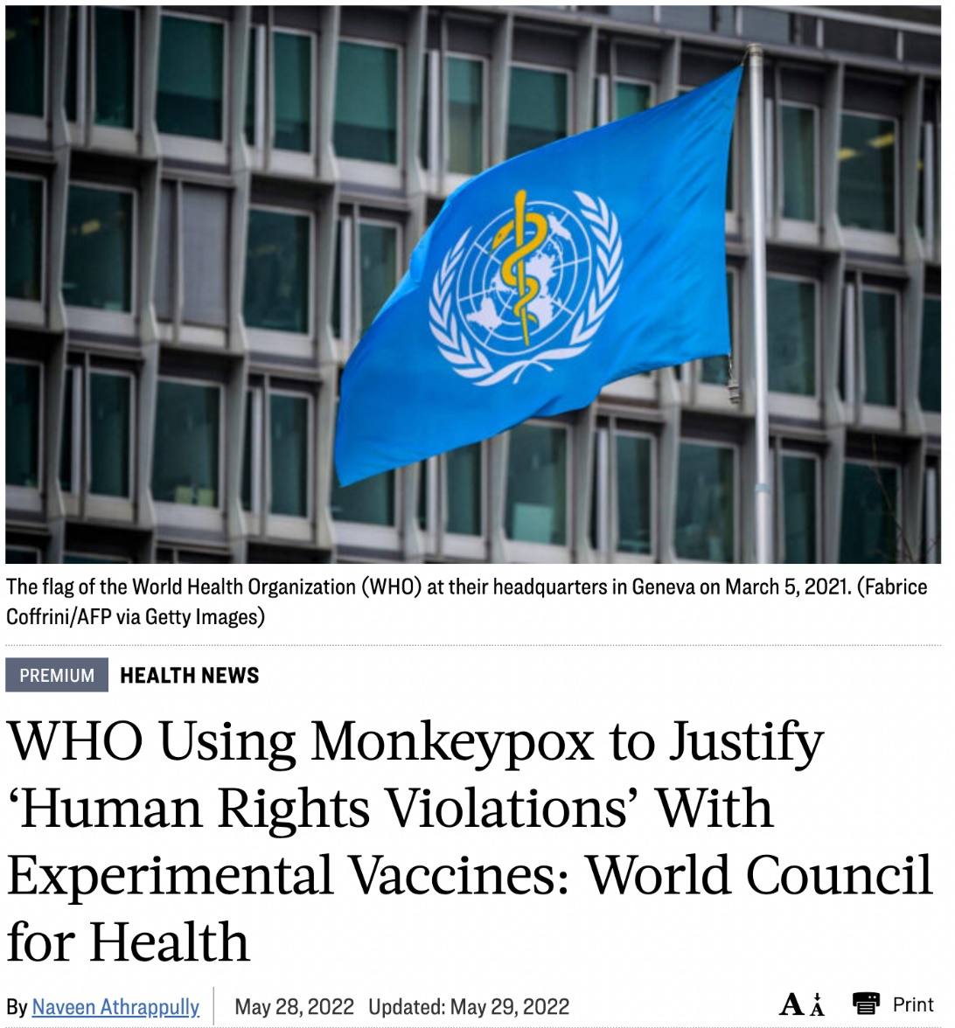
Link here.

One day after the close of the Maspalomas Gay Pride superspreader event. Link Here.
Emergent BioSolutions, already flush with products against public health threats like anthrax attacks and opioid overdoses, is expanding its arsenal of medical countermeasures by scooping up global rights to smallpox newcomer Tembexa.
Emergent will furnish developer Chimerix with $225 million in upfront cash plus upward of $100 million in milestone payments for worldwide rights.

Who is Robert Malone is a reader-supported publication. To receive new posts and support my work, consider becoming a free or paid subscriber.
Subscribe now

The Malone Institute
1,043 likes
1,043

235

235 Comments

Joseph Carroll
Writes StewardMay 31·edited May 31
Anyone who has not arrived at the conclusion that a Luciferian death-cult is in full-court press mode needs to wake up. It's long past time to take out the trash.

219ReplyCollapse
Big E
May 31
They will release progressively uglier and more gruesome diseases upon us...UNTIL we realize that THEY are the uglier and more gruesome diseases.
Honestly, I'd rather die of their ugly, gruesome diseases than live in their physical and psychological clutches. We must apply The Great Barrington Declaration precepts (https://gbdeclaration.org/) and then ignore the monkeyporn mongerers.
My Mom offered me some wisdom decades ago, which may apply here: Ignore the brats and they will go away! I hope she was right!

157ReplyCollapse
18 replies
233 more comments…
[Within the '233 more comments…' search for 'Liked by Robert W Malone MD, MS' to find a bit more of Robert W Malone on the subject above, . Here ends my commentary on Malone's May 31 Monkey Pox Update. -FNC]

TopNewCommunity
What if the largest experiment on human beings in history is a failure?A report from an Indiana life insurance company raises serious concerns.
ROBERT W MALONE MD, MS
JAN 2
2,868

514

Open Letter to the Canadian Truckers.These are my truths, and I believe that they are self-evident.
ROBERT W MALONE MD, MS
FEB 10
3,736

252

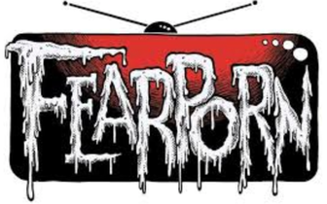
Monkey PoxTruth versus Fearporn.
ROBERT W MALONE MD, MS
MAY 21
2,601

216

See all

Ready for more?
Subscribe

